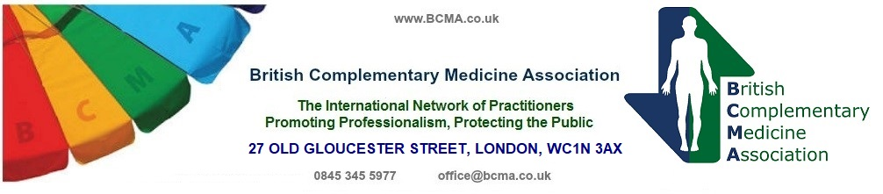

Sponsoring Organisation Declaration for
Affiliated Schools/Colleges.

(Please note: Sponsoring Organisations must be Full Member Organisations of the BCMA)

Please complete in full, in block capitals.

(This sheet may be photocopied)

The (name of member organisation sponsoring this school/college)

__________________________________________________________________________
Confirms that (name of school/college)

___________________________________________________________________________

is a full member and recognised School/College of the above named Organisation.

We undertake to notify the BCMA if this School/College ceases membership of our Organisation.

Signed and stamped on behalf of our Organisation:

___________________________________________________________________________

CHAIR \ TREASURER \ SECRETARY

Print name(s)______________________________________Date___________________________

BRITISH COMPLEMENTARY MEDICINE ASSOCIATION
27 OLD GLOUCESTER STREET, LONDON, WC1N 3AX

Tel: 0845 345 5977

