**BCMA Bodywork Registered Affiliate Website Listing Form**

**Please fill in your details below clearly in black ink and printed capitals**

Country



County



Town/Area



Postcode (first part only i.e. BH8) _______

Name

(as you would like it displayed)

BCMA member organisation/school/Registered Affiliate

Bodywork Registered Affiliate



Telephone number for display on website



Email Address



Your Website

Please link back to the BCMA from your website.

Therapies for which you are fully qualified and insured and previously

sponsored by the APNT

Any other therapies should be marked as independent below and copies of your qualifications and insurance must be included for these and sent to the BCMA office



Example of listing

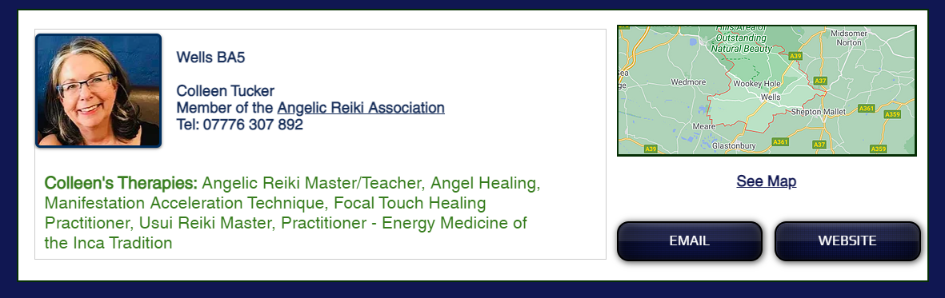

Please send a profile picture or URL of your picture if you would like it included to [tracy@bcma.co.uk](mailto:tracy@bcma.co.uk)