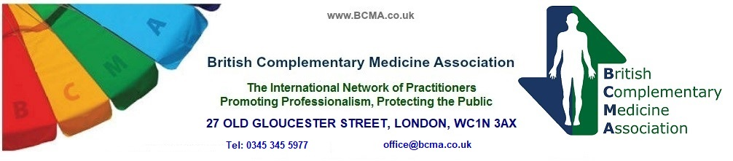

BCMA Bodywork Registered Affiliate Renewal Form

Please complete in block capitals with a black pen

Past BCMA Member Association – Association of Physical & Natural Therapists

Practitioner Name………………………………………… Membership no. ………...
(As you would like it to appear on the certificate) (BCMA reg. number if known)

Address …………………………………………………………………………………

Town……………………………………….. County …………………………………

Postcode …………………………………… Email…………………………………..

Telephone Number ………………………… Mobile …………………………………

Website …………………………………………………………………………………

The details above may be used for referral purposes by the BCMA -
On the BCMA Website Yes No
(Please circle your preference - your details will include County, Town, and contact info from above)

Signed……………………………………... Date……………………………………..
(Practitioner)
I confirm I was a member of the Association of Physical & Natural Therapists and have insurance cover (enclosed) for the following therapies –

…………………………………………………………………………………………..

…………………………………………………………………………………………..
If you require details of BCMA discounted insurers, please contact the office. Please note that a copy of current insurance should be included with this form. Please send a copy of your CPD Activity Form for last year.

I enclose the fee of £70 or I have paid the fee via bank transfer on (date)

Please Include your insurance details and the fee to - BRITISH COMPLEMENTARY MEDICINE ASSOCIATION, 27 OLD GLOUCESTER STREET, LONDON, WC1N 3AX or preferably pay via bank transfer and email this form to office@bcma.co.uk include your name as the payment reference. Bank Details - Account Name: British Complementary Medicine Association
Barclays Bank plc Sort Code: 20-69-17
Portman Square Group
London. W1A 3AL Account No: 50689335

