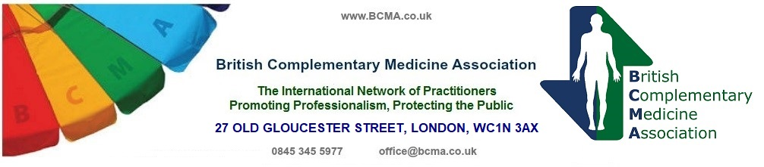
Independent Membership Application for Schools/Colleges Overseas

Thank you for applying for membership of the BCMA.
Please answer all questions in full in block capitals to avoid delays in processing your details. We are in a position to give schools/colleges direct referrals by entering their details onto the BCMA website. Please Complete the Website listing form attached

Section 1. Name, Address and Contact Numbers

Full Name of your School/College: __________________________________________

Address: ______________________________________________________________

____________________________________________________________________________________

Tel No. ___________________________________ Fax No. _____________________

Email _________________________________________________________________

Website _______________________________________________________________

Name of Principal: ______________________________________________________

Section 2. Supporting information (to be attached please)

- Confirmation of the overall duration of the current formal training that your school/college offers in hours/months.
- Copy of the training syllabus.
- An outline of the aims and objectives of your school/college.
- A copy of the Code of Conduct with which members of your school/college must comply, if it differs from that of the BCMA.
- A copy of your Complaints, Grievance and Disciplinary Procedure
- A list of your current teaching staff with their teaching qualifications and their experience i.e. has each teacher had 2 or more years qualified teaching experience in the therapy they are teaching?

Section 3. Your Formal Application

I/We hereby apply for Independent School Membership of the British Complementary Medicine Association.

I/We have read the BCMA Code of Conduct.

I/We agree to comply with all its terms.

I/We commit to maintain and, where possible, to raise our Training, Education and Practice Standards.

Signed on behalf of the school/college by:

Signature of Principal: ___________________________________________________

Print Name: ___________________________________________________

Date: ___________________________________________________

Please pay by bank transfer £250, (including the one-off administration fee of £100 and the annual application fee of £150 due in April each year).
payable to BCMA, together with your supporting information to:
BRITISH COMPLEMENTARY MEDICINE ASSOCIATION
27 OLD GLOUCESTER STREET, LONDON, WC1N 3AX

Cheques should be made payable to: The British Complementary Medicine Association
or payment made direct to The BCMA account with Barclays Bank Plc
Sort Code – 20-69-17 Account No 50689335
SWIFTBIC = BUKBGB22
IBAN = GB75 BUKB 2069 1750 6893 35
You should then forward documents along with confirmation of payment to office@bcma.co.uk

Independent school criteria
It will be necessary for any teaching establishment to match the criteria set out by the BCMA inspection panel.
These criteria will include the necessity for teachers to –
A. Be qualified in the subjects they are teaching
B. Hold a teaching qualification such as the City & Guilds 7307
C. Be insured
D. Have at least two years practical experience of their therapy.

Proof of teacher qualifications will have to be provided. If the content of the course and an examination are devised by the training establishment, it is recommended that the NVQ Assessors award D32/33 and an Internal Verifiers Certificate D34 be held or equivalent.
The teaching establishment must hold adequate professional indemnity and public liability insurance, which specifically includes teaching and training establishment activities. It will be necessary to provide proof of insurance to the BCMA at the time of application. It will also be necessary to provide the BCMA with the syllabus of the course or courses run at the establishment, along with a scheme of work, and the statement of Aims and Objectives of the courses being taught.
Besides these requirements there will be an onsite inspection (see further information document) to see that the premises are suitable for the subject being taught. Inspection will include observation of the teaching skills of teachers and their inter-action with students, the equipment used, e.g. flipcharts, overhead projector etc and how well they are used within the context of the subjects being taught. (the travel costs of the inspector will be covered by the school)
The teacher/lecturer should ensure that the premises being used do meet the Health and Safety regulations and must ensure to acquaint themselves with fire exits, fire extinguishers & Defib location if any and include that in their opening statement.
A basic fee of £250 will be charged to cover the cost of the membership process. Should a re-inspection become necessary then it will be necessary to charge a further fee. In the second and subsequent years there will be an annual registration fee, which is currently £150. This sum may be reviewed at future A.G.M.’s.

Overseas schools
Instead of an onsite inspection overseas schools will be sent a list of further required information and details of how this should be presented this will include but not be limited to –
Live skype/video of the classroom
Details of handouts/class room aids used
Interview with the principle and or main tutors
Details of availability of tutors outside of class hours for students
Details of the laws of teaching in the country the school is based.

